**Lab 3 [Generate Unit Tests]**

**Generate and run unit tests**

This scenario is for validating the upgrade and modernization. Here we will generate the unit test to validate that all the new methods are correct and free from any error.

1. Right click on the project, select **watsonx Code Assistant for Enterprise Java Applications,** then selectGenerate Tests.

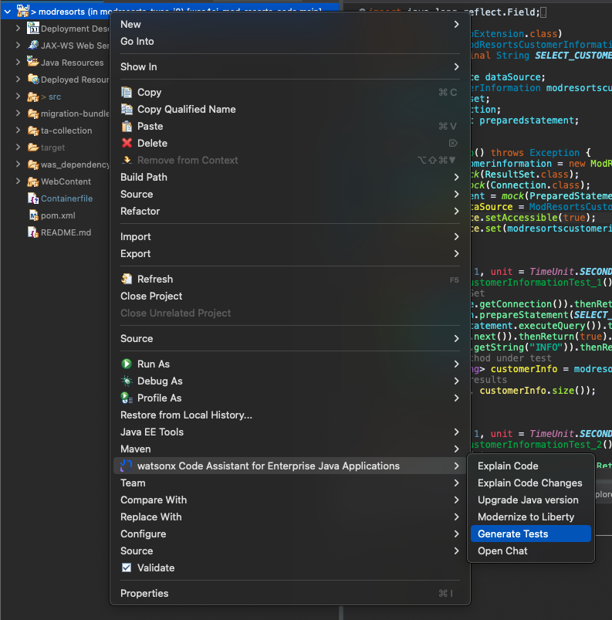

1. You can choose to generate tests for the entire project, or can select just 1 single java file. If you choose the entire project, there will be a new test folder with unit tests being generated:

1. You can right click on any generated test, and run it as jUnit Test

